OCEANA COUNTY
JUNIOR MARKET
TURKEY RECORD BOOK - 2023
(for ages 5-7)

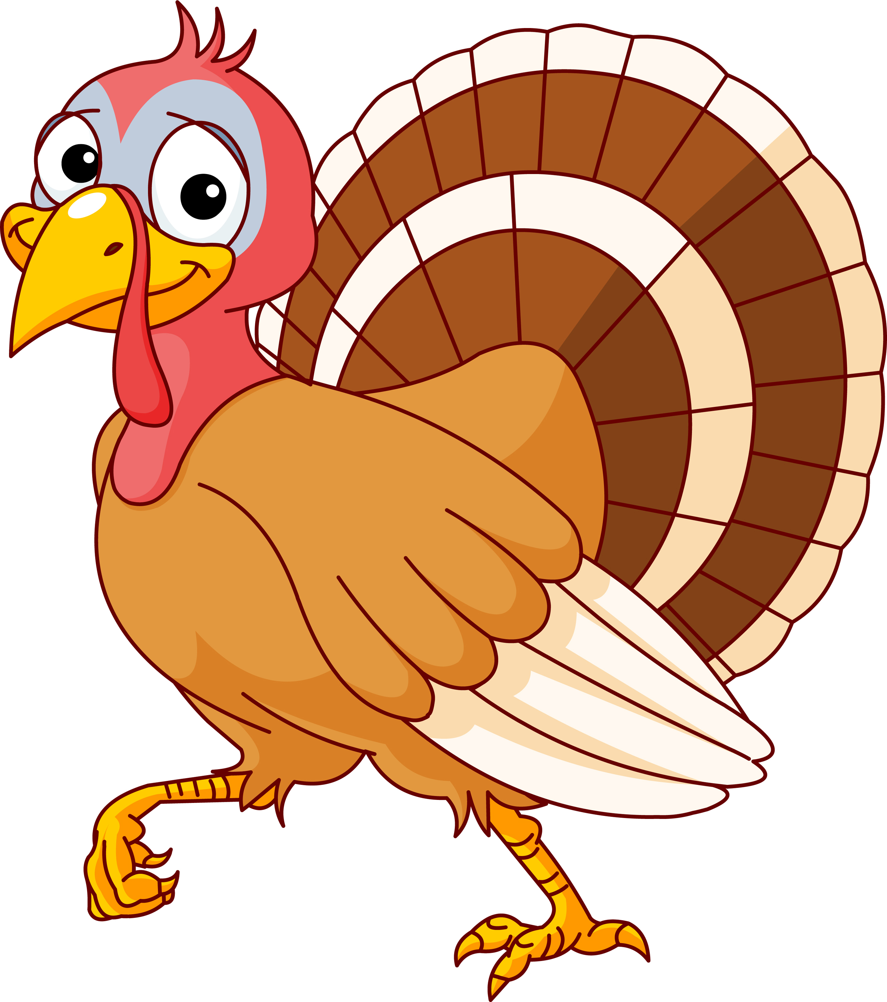

As a member of the Junior Market Animal Project, you are required to submit your records as part of an educational project notebook in order to show your animal at the Oceana County Fair. This notebook must be shown to the Poultry Superintendent or designated Small Market Weighmaster at the time of weigh-in and then entered by you in the Educational Notebook Division at the Oceana County Fair on Entry Day.

IF YOU ARE A LITTLE BUDDY PLEASE CHECK HERE: _____

My big buddy is: _________________________________________

NUMBER OF YEARS IN PROJECT: __________

AGE: __________
Your age you enter depends on how old you were on January 1, 2023.

Use this sheet as the first page of your project record book. Fill it out completely.

Please print or type neatly.

NAME ________________________________________________________________

4-H CLUB _____________________________________________________________

LEADER _______________________________________________________________

DATE RECORDS STARTED ______________ DATE ENDED _______________

JUDGE’S SCORE/COMMENT SHEET

(PLEASE DO NOT REMOVE, PLACE THIS SHEET IN SHEET PROTECTOR OR GLUE TO COVER). This sheet must be keep free to the judge to write their comments.

This sheet should help the junior market member understand their ribbon placing.

A. Specific educational value or worth

___ All questions were answered completely

___ All calculations were correct

___ Calculations were incorrect

___ Questions were not completely answered

___ Questions were not answered (missed questions)

B. Notebook contains all project records

___ Notebook contained all project records and were fully completed

___ Notebook contained additional project related information (research

materials etc.)

___ Project records were incomplete

___There was no additional project related information

C. Accuracy, neatness and general appearance

___Notebook was neat in appearance (typed/hand printed)

___ Notebook pages were clean and stain free

___Notebook pages were in order and complete

___Notebook pages were out of order and missing pages

___Notebook was difficult to read and messy

___Notebook had wrinkled and stained pages

Other Comments: ________________________________________________________________

______________________________________________________________________

2023- Junior Market Turkeys PAGE 2

OBJECTIVES
- Develop desirable work habits, sportsmanship, and ability to cooperate and express ideas through participation in projects, discussions, method demonstrations, judging teams, and exhibits.
- Experience the pride and responsibility of leasing/owning and caring for poultry.
- Learn how to feed, fit, show, breed and raise poultry.
- Learn proper handling procedures to prevent injuries to members and their poultry projects.
- Appreciate and use scientific information in poultry production and marketing.
- Improve knowledge of grading, marketing and merchandising of poultry and poultry products.
- Improve knowledge of the nutritive value of poultry meat and eggs and how they contribute toward good health.
- Learn the importance of the poultry industry to the local, state, and national economies.
- Acquire information on the opportunity that poultry offers as a career.
This record book is part of your Junior Market Turkey project. By keeping records up-to-date you will be able to see how much progress you make as you set goals and work to accomplish them. Write or type neatly and clearly. Please keep the pages in order. Feel free to add extra pages at the end of your notebook. Pictures are a required part of your notebook. Taking pictures of your project animal throughout the project will indicate how your animal has grown and developed. Add pictures to your notebook on a separate piece of paper.

SCORING CRITERIA
The following breakdown will be used during the judging process of all market livestock notebooks.

A. Specific educational value or worth 30%
B. Creative way of showing what has been learned 10%
C. Notebooks contains all project records 50%
D. Accuracy, neatness and general appearance 10%

The Oceana County Agricultural Society encourages parent assistance with your project and project notebook.
If a parent or adult helped you in filling out your notebook please have them sign below that the answers are YOUR answers and that they assisted you in writing of the answers and understanding of the questions only.

_________________________________________________________
(Signature of person helping with notebook)

_________________________________________________________
(Printed name by member)

2023- Junior Market Turkeys PAGE 3

My Turkeys Names are: (if you did not name your market turkeys, what is the name of your showmanship bird)

__________________________________________________________________________________

My Turkey’s breeds are:______________________________________________

What color are your Turkeys: __________________________________________

My Turkey’s favorite thing to do is: _____________________________________

__________________________________________________________________________________

WEIGHT CHART

Date | Age | Weight

FINAL WEIGHT (FW)___________ AGE__________ DATE___________
*Final weight may need to be estimated depending on Covid restrictions

2023- Junior Market Turkeys PAGE 4

EXPENSES

(A) Cost of poults $_______________________

DATE | LBS. OF FEED | FEED TYPE / VARIETY | COST
 |  |  | $
(B) |  | TOTAL SPENT ON FEED | $

DATE | OTHER EXPENSES, VET, SUPPLIES, HOUSING, ETC. | COST
 |  | $
(C) | TOTAL SPENT ON OTHER EXPENSES | $

GRAND TOTAL OF ALL EXPENSES (TE): $ _______________________
(total of A, B and C)

_______________ ÷ _________________ = _________________________________________
Total Expenses (TE) Final Weight (FW) Break Even Price (BE)
(or total cost per pound to raise your animal)

** have your parent, leader or an older teen in your club help you figure out your breakeven price. The breakeven price is the price that you need to get at the
Junior Market animal auction in order to not lose money on your market project. **
2023- Junior Market Turkeys PAGE 5

ANIMAL CARE AND MANAGEMENT- JOURNAL OF CARE

Your project requires regular care and management.
Include the following:
- Feeding and watering practices
- Health practices and medicines (vaccinations, etc.)
- General Management (building a cage, cleaning living area, feed pans, etc.)

Daily- Things done once or twice a day
Weekly- Things done once or twice a week
Monthly- Things done once a month
Yearly- Things done one time or occasionally throughout the year
2023- Junior Market Turkeys PAGE 6

MARKETING

One of the most important parts of any market animal project is marketing. This may include writing letters and talking to prospective buyers. Color in the face, a smiling face is a good action, a frowning face is a bad action. (see the example)

Good Marketing Practice Poor Marketing Practice

Send a picture to your potential buyers

Send a reminder to attend the auction

Let an adult talk to the buyer instead of
you talking to them

Know what kind of feed you used if asked

Only go to grocery stores or the banks

Make sure to visit your previous buyers

Only thank those who agree to be listed as a potential buyer







WHAT DOES YOUR TURKEY NEED?
(have an adult help you read the following & then circle those items that your chickens need)

All living creatures need certain things to survive, like food, water and shelter. Farmers take care of their animals to make sure they are healthy and comfortable. If any chickens are sick the farmer will treat them with the help of the veterinarian. Turkeys like to find bugs to eat as they scratch the ground.
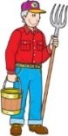
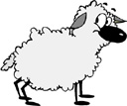
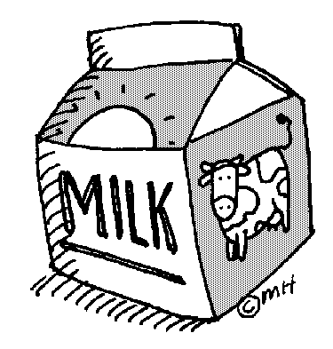
FARMER CAKE  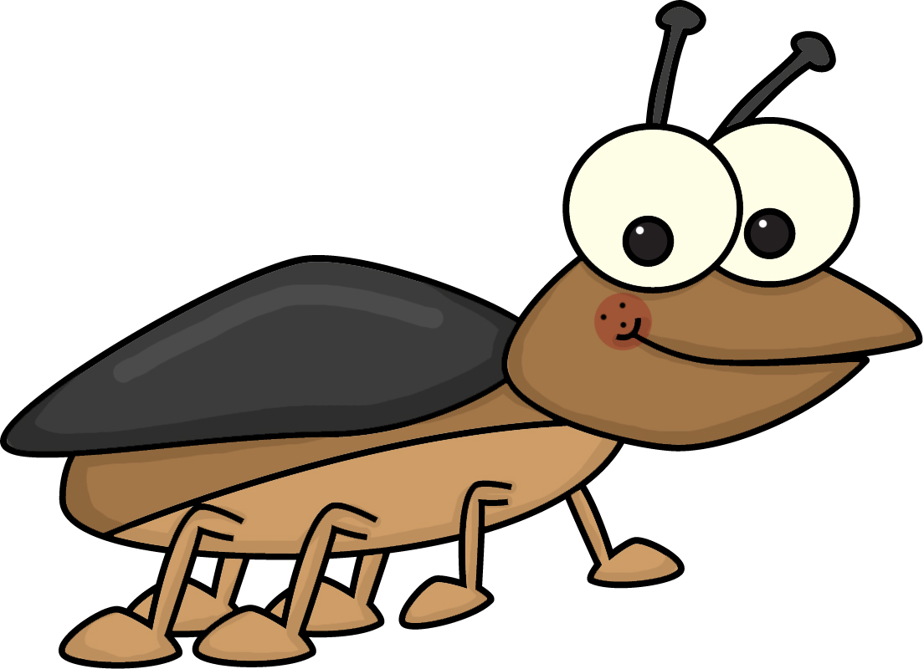 
BARN
FARMER
BIKE
JUICE
WATER
CLOTHES
MILK
CORN
VETERINARIAN
TV
CAKE
CHOLOLATE CHIPS BUGS VETERINARIAN

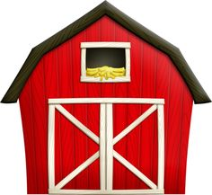
SHELTER WATER
2023- Junior Market Turkeys PAGE 7

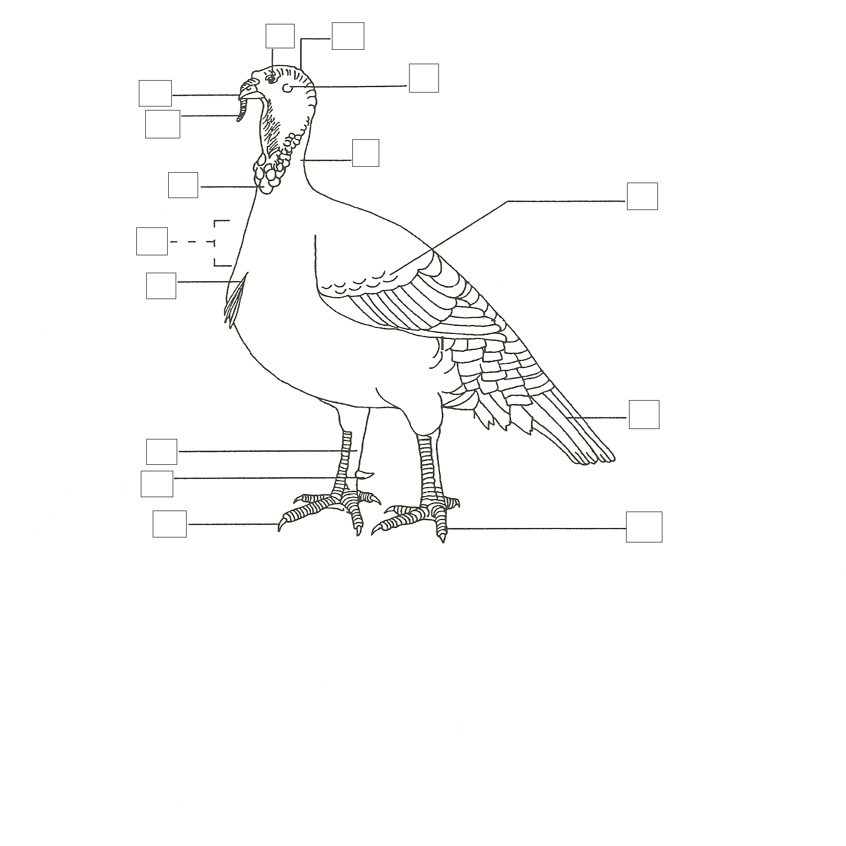
IDENTIFY THE PARTS OF THE TURKEY
(fill in the boxes in the above picture with
the letter corresponding to the correct part)

A. BEAK F. SHANK K. CARUNCLE
B. BEARD G. CROP AREA L. CROWN
C. COVERTS H. TOE M. NECK
D. TOENAIL I. EAR N. SNOOD
E. TAIL FEATHERS J. EYE O. SPUR

2023- Junior Market Turkeys PAGE 8

TRUE OF FALSE
(circle T for True or F for False)

- Placing a bird in its carrying crate a couple of times
before show day is a good way to train it to be calm T F
when it is in its crate.

- When removing a bird from its cage, you should remove
its head first. T F

3. If your bird moves both legs during posing, keep trying to
repose it until you get it to stand still. T F

4 When cleaning your bird’s feathers, go from head to tail; do not go against the feathers. T F

5. A place where poultry are housed or exhibited is a stall. T F

6. During judging be alert & smile, look at the judge from time to
time and be courteous. Answer the judge’s questions
politely using the words “sir” or ma’am.” T F

7. A cloverbud is a 4-Her ages 5-8 who must have an adult close
Page 9
SMA Chickens
by when handling their poultry animals. T F

8. For your market project you must sell a pen of 3 turkeys. T F

9. Each market turkey must weight a minimum of 7 pounds. T F

10. All poultry must be checked for pollorum on entry day of Fair
at the Oceana County Fair. T F

11. You must accumulate 9 points in order to sell your animal,
6 from 4-H meetings and 3 from nonclub points. T F

12. You can learn the breeds by studying the Standards of
Perfection. It will also tell what a “perfect” bird is. T F

13. Water is NOT very important to your turkey, if you forget to
give it fresh water frequently it is okay. T F

14. You will show your market turkeys during showmanship. T F

2023- Junior Market Turkeys PAGE 9
PROJECT INFORMATION

What Does Not Belong?
In each statement, one word does not belong, X (cross) out that word.

1. Turkeys have: feathers, gizzards, beaks, manes

2. Turkeys eat/drink: insects, green potato skins, pellets, grasses

3. The people who help me take care of and learn about my flock are:
the police, my club leader, the veterinarian, my parents

4. Turkey breeds: Broad Breasted White, Broad Breasted Bronze,

White Holland, Suffolk

Finish the Sentences

1. My flock always needs clean, fresh ___________________________________ to drink.

2. When I grow up I want to be a _________________________________________________.

3. The best, or most fun, part of my project was: __________________________________

_______________________________________________________________________________

_______________________________________________________________________________

______________________________________________________________________________

4. The hardest part of my project was: _________________________________________

_______________________________________________________________________________

_______________________________________________________________________________

_______________________________________________________________________________

2023- Junior Market Turkeys PAGE 10

IDENTIFY GOOD AND BAD CHARACTER ACTIONS

Color in the face, a smiling face = a good action; a frowning face = a bad action.

RAISING and SHOWING an RAISING and SHOWING an
ANIMAL with CHARACTER ANIMAL without CHARACTER

Feed Animals on Time

Complain about the judge

Clean cages daily

Thank the judge for their time

Congratulate whoever places first

Ask for help

Leave animals outside without shelter

Take others equipment without asking

Have someone else do your record book

Insult competitors

/

/

/

/

//4-H INFORMATION

/

How did you show good character this year? Did you help someone, or maybe you treated your animals extra special?

__________________________________________________________________________________________

__________________________________________________________________________________________

__________________________________________________________________________________________
2023- Junior Market Turkeys PAGE 11

JUST FOR FUN
CONNECT THE NUMBERS 1-60 TO COMPLETE THE TURKEY.
THEN COLOR HIM HOWEVER YOU LIKE.

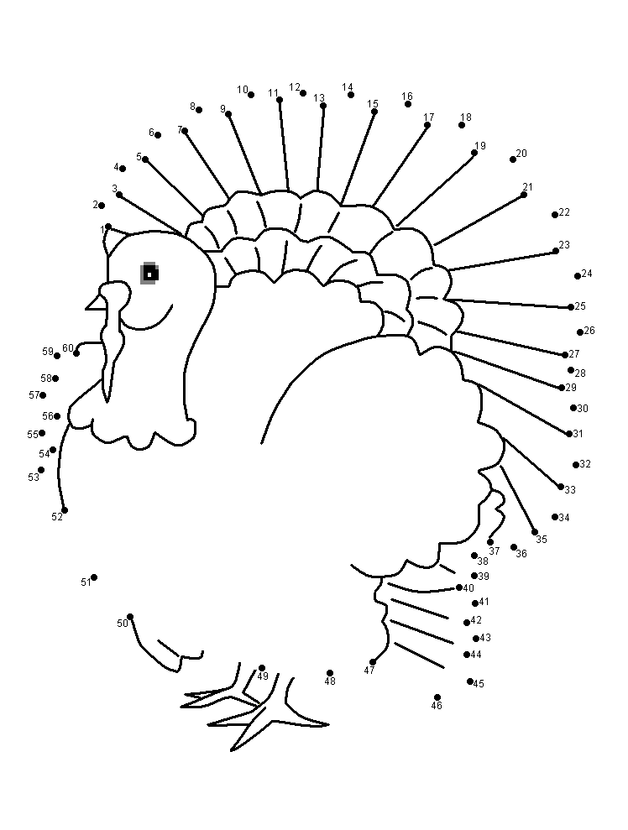
2023- Junior Market Turkeys PAGE 12

4-H KNOWLEDGE
The 4-H Pledge- Draw a line to the picture that fills in the blank (see the example)

I pledge…










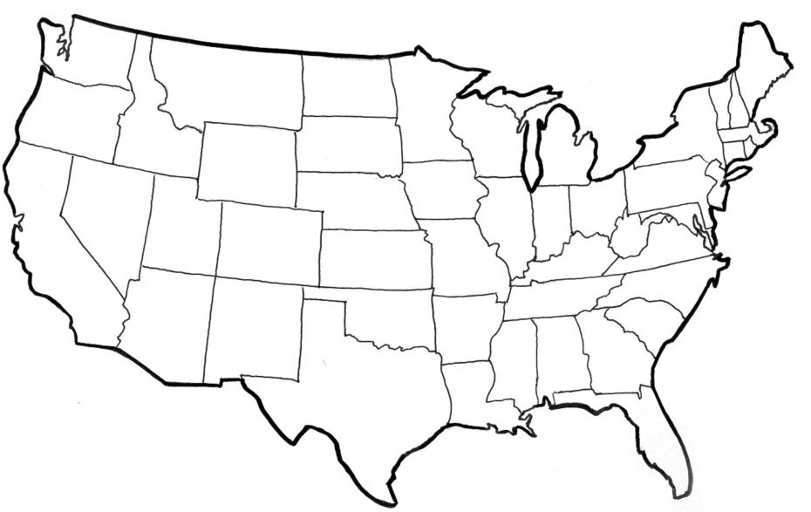




HANDS

HEALTH

HEAD

HEART

WORLD

COUNTRY

CLUB

COMMUNITY

My ____________ to clearer thinking,

My ____________ to greater loyalty,

My ____________ to larger service, and

My _____________ to better living,

for my ____________________,

my _______________________,

my _______________________,

and my ____________________.

Number of club meetings held: __________ Number I attended: _________

2023- Junior Market Turkeys PAGE 13
MY STORY

(Interesting things that happened to me and my animal this year, challenges, highlights of my year or anything else I would like to share about
my overall experience)

POTENTIAL BUYERS NAMES

As part of your 4-H Small Market Livestock Project, you must personally contact at least three potential buyers before the Oceana County Fair. You are encouraged to seek two new buyers that have not been asked or submitted before. You also must have at least three different buyers than those of your siblings in the market livestock project. Please confirm with your buyers their accurate mailing address (example: post office box vs. a street address). The information on page 14 must be completed and taken to the Oceana County MSU Extension Office on or before the due date where it will be copied and used to send out letters to your potential buyers. This page will remain in your notebooks. This is a Market Livestock Committee rule. Failure to comply will result in not being able to sell your animal in the 4-H Market Livestock Sale.

Page 14 Date: _______________
2023- Junior Market Turkeys Staff: _______________

JUNIOR MARKET/SMALL MARKET POTENTIAL BUYER’S LIST
TURKEY PROJECT (AGES 5-7)

Name______________________________ Club_________________________
Please print business names and complete addresses clearly.

  - Contact Name ____________________________________________________

Business Name ____________________________________________________

Mailing Address _________________________City_________________Zip_____

Phone _______________________ After Hours Phone______________________
Mailing Preference (Please Check One): Email ____ Postal Delivery ____

Email ____________________________________________________________

Signature__________________________________________________________

2. Contact Name ____________________________________________________

Business Name ____________________________________________________

Mailing Address _________________________City_________________Zip_____

Phone _______________________ After Hours Phone______________________
Mailing Preference (Please Check One): Email ____ Postal Delivery ____

Email ____________________________________________________________

Signature__________________________________________________________

3. Contact Name ____________________________________________________

Business Name ____________________________________________________

Mailing Address _________________________City_________________Zip_____

Phone _______________________ After Hours Phone______________________
Mailing Preference (Please Check One): Email ____ Postal Delivery ____

Email ____________________________________________________________

Signature__________________________________________________________

(Must be stamped by the MSU Extension Office)

2023- Junior Market Turkeys PAGE 15
Page 8
SMA Chickens
HATCH
PULLET
VENT
SCALES
COOP
HEN
ROASTER
PUREBRED
EMBRYO
ROOSTER
MOLT
SHANK

PICTURES OF YOUR PROJECT

(Please use this page for your project pictures. Add additional pages if you would like. The judges appreciate you labeling the pictures so they know what the picture shows.)
NON-CLUB POINTS- JUNIOR/SMALL MARKET PROJECT
(This must be filled out by participant before presenting for signatures at the MSUE office)
MEETING NAME | LOCATION | DATE | POINTS | SIGNATURE OF LEADER, SUPERINTENDENT OR MSU STAFF
Please note: This form must be included with your record notebook and turned into the weigh master on entry day of the Fair. BEFORE SEEKING SIGNATURES AT MSU EXTENSION – MEETING NAME AND DATE MUST BE COMPLETED You need to accumulate nine (9) points to be allowed to sell your animal. Six (6) of these nine (9) points must come from club meetings. The three (3) non-club points must be earned from attending various 4-H events and activities. See your leader, the MSUE office, or online at https://www.canr.msu.edu/oceana/oceana_county_4_h/oceana_4_h_market_livestock for a listing of approved nonclub points.
JUNIOR/SMALL MARKET PROJECT CLUB POINTS
(This must be filled out by participant before presenting for signatures at the MSUE office)
MEETING NAME | LOCATION | DATE | POINTS | SIGNATURE OF LEADER, SUPERINTENDENT OR MSU STAFF

Please note: This form must be included with your record notebook and turned into the weigh master on entry day of the Fair. You need to accumulate nine (9) points to be allowed to sell your animal. Six (6) of these nine (9) points must come from club meetings. The three (3) non-club points must be earned from attending various 4-H events and activities

